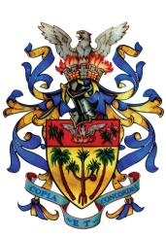

50th Independence Anniversary
&
Civic Week 2017

Independence Torch Relay and
Torch Lighting Ceremony

Sunday 27 August 2017 at 11 am
Plaines de L’Hermitage to
Town hall VAcoas
Programme

Time
12.05 pm | Announcement
12.10 pm | Torch Lighting Ceremony
12.10 pm | Dance Performance by D.Bauda &  Group
12.15 pm | Remilla Music School
12. 25 pm  12.35 pm | Dance Performance by D.Bauda  and Group  Speech by Eminent Personalities
12.50 pm | Dance performance by Kwame Group
1.00 pm | Musical Performance by D.Bauda-  Sega
1.10 pm | Vote of Thanks

Programme
Time
11.00 am | Arrival of Guests
11.05 am | Bongo Dance by Kwame Group
11.08 am | Announcement
11.10 am | Parade by SMF and Bagpipers
11.20 am | Handing Over Ceremony from the District  Council of Moka to the Municipal Council of Vacoas/Phoenix
11.25 am | Procession/Defile
11.30 am | Independence Torch Relay
11.45 am | Procession/Defile form Dr Maurice Cure SSC  via the Town Centre to the Town Hall
Noon | National Anthem

